AI Business Application
Final Project
Course Name: | MIS-571: Artificial Intelligence for Business Applications
Module: | Module 6
Project Title: | AI-Powered Classification and Summarization of Mortgage Servicing Legal Documents Using NLP and Machine Learning
Student Name(s): | Rashee Lott
Instructor: | Dr. Rajan Thapaliya, Ph.D.
Date: | July 2026

1. Introduction and Background
Mortgage servicing organizations routinely review county-recorded legal documents, including mechanic's liens, lis pendens, judgments, tax liens, releases, satisfactions, and mortgage assignments. Analysts must identify the document type, locate key facts, determine whether the record may affect the subject property or loan, and prepare a concise business summary. The process is repetitive, time-consuming, and vulnerable to inconsistency, especially when records are scanned, poorly formatted, or written in unfamiliar legal language. The issue affects analysts, managers, compliance teams, title researchers, attorneys, investors, and customers because delays or errors can affect lien monitoring, foreclosure timelines, title research, reporting, and customer service (Consumer Financial Protection Bureau [CFPB], 2024).
The decision that needs improvement is the first-stage classification and summarization of a recorded legal document. A non-AI keyword checklist could help with simple cases, but it would be rigid and difficult to maintain across multiple document types and wording variations. AI and machine learning are reasonable because natural language processing can convert document text into numerical features and identify patterns associated with legal-document categories (IBM, n.d.). The intended users are mortgage-servicing analysts and managers. A better process would produce faster first reviews, more consistent labels and summaries, fewer avoidable errors, and a clear route for uncertain cases to human reviewers.
The main constraints are limited access to real mortgage-servicing documents, the short project timeline, privacy concerns, and the need for human oversight. Therefore, the prototype uses simulated data and does not process real borrower, account, or customer information. It is a decision-support tool, not a legal opinion or automated servicing decision.

2. Proposed AI Approach
The project uses a classification task supported by natural language processing. The selected technique is TF-IDF text vectorization followed by logistic regression. TF-IDF assigns numerical importance to words and short phrases, while logistic regression learns which features are associated with each document category. The model predicts one of eight classes: mechanic's lien, lis pendens, judgment, tax lien, release, satisfaction, assignment, or other. A rule-based extraction layer then identifies a date, dollar amount, and property address when present. Finally, a controlled template produces a short business summary and a human-review notice.
This technique is appropriate because the input is unstructured legal text and the desired output is a clear category with an interpretable confidence score. Logistic regression is simpler and easier to explain than a deep neural network, yet it is strong enough for a small proof-of-concept text-classification project. The original proposal discussed LLM-assisted classification and summarization; however, the final implementation uses classical NLP and supervised machine learning to keep the project reproducible, private, and manageable. An approved enterprise LLM could be added later for more flexible summaries (Microsoft, n.d.).
To control scope, the prototype does not perform OCR on real PDFs, give legal advice, determine lien priority, make foreclosure decisions, integrate with a servicing platform, or process confidential borrower data. It also does not attempt handwriting recognition, multi-page document reconstruction, or production deployment.

3. Research Findings (Brief)
Research shows that NLP is commonly used to classify, extract, and summarize business documents. IBM (n.d.) describes NLP as a group of techniques that allows computers to process and understand human language. Microsoft (n.d.) explains that large language models can support summarization, classification, and question answering. In mortgage servicing, AI must operate within a regulated process. The CFPB (2024) provides mortgage-servicing compliance resources, and Fannie Mae (2026) emphasizes governance, monitoring, and controls when AI or machine learning is used in mortgage-related practices.
Similar business solutions include automated contract review, document routing, customer-message classification, and extraction of key terms from financial and legal records. Typical data includes document text, labels assigned by subject-matter experts, OCR output, recording dates, parties, dollar amounts, addresses, and approved summaries. Common classification metrics are accuracy, precision, recall, F1-score, and confusion matrices. High performance is useful only when the test data represents real operating conditions and the cost of errors is understood.
The literature and industry guidance also identify important risks. Models can produce inaccurate outputs, perform unevenly across document formats, expose confidential data, or encourage overreliance. Taulli (2019) notes that AI raises concerns involving privacy, accountability, and oversight. For this use case, the most important safeguards are data minimization, secure systems, audit trails, representative testing, confidence thresholds, and trained analysts who verify every result.

4. Data (Real or Simulated)
The dataset is simulated because real mortgage-servicing records may contain confidential borrower and loan information. It contains 96 fictional document texts, with 12 examples in each of eight categories. One row represents one recorded legal document. The target variable is the document category. The primary input feature is the document text, which contains realistic terms such as notice of lien, lis pendens, judgment, release, satisfaction, tax warrant, assignment, recording date, amount, and property address.
The simulated documents use fictional parties, amounts, dates, and New Jersey-style addresses. The data preparation process converts text to lowercase, removes common English stop words through the vectorizer, and creates unigram and bigram TF-IDF features. The dataset is split into 75% training data and 25% test data using stratification so that every category is represented equally in both sets. No missing values or numeric outliers were present because the data was generated in a controlled format.
Privacy was protected by avoiding all real names, loan numbers, email addresses, account identifiers, and customer records. Although fictional property addresses appear in the prototype, a production system should mask or tokenize addresses and parties unless those fields are necessary and processed in an approved secure environment.

Dataset Dictionary
Field | Meaning | Role in Model
document_id | Fictional unique identifier | Tracking only
document_text | Simulated recorded-document text | Primary input feature
actual_type | Human-assigned document category | Target label
predicted_type | Category predicted by model | Model output
confidence | Highest predicted probability | Review-routing aid
business_summary | Generated first-review summary | Decision-support output

5. Implementation (Python)
The implementation was created for Google Colab using Python. The main libraries are pandas and NumPy for data handling, scikit-learn for TF-IDF, logistic regression, train-test splitting, and evaluation, matplotlib for visualization, and regular expressions for extracting dates, dollar amounts, and addresses.
The workflow follows six steps. First, the program creates the simulated dataset. Second, it splits the data into 72 training documents and 24 test documents. Third, TF-IDF converts the text into numerical word and phrase features. Fourth, logistic regression is trained on the labeled training records. Fifth, the model predicts the test categories and calculates confidence scores. Sixth, the program evaluates performance, extracts key fields, produces business summaries, identifies cases requiring human review, and exports the results.
A simple majority-class baseline would achieve 12.5% accuracy because the eight classes are evenly balanced. The trained model substantially exceeds that baseline on the simulated test set. One improvement attempt was the use of both unigrams and bigrams instead of single words alone. Bigrams allow the model to recognize meaningful phrases such as 'tax lien,' 'lis pendens,' 'final judgment,' and 'mortgage assignment.' A 60% confidence threshold was also added so uncertain cases can be routed to an analyst.
In plain language, the code teaches the model which words and short phrases tend to appear in each type of legal document. It then uses those patterns to classify a new document. The extraction functions search the text for recognizable date, currency, and address patterns. The summary function combines the model output with the extracted fields and explains the possible servicing relevance while clearly requiring human verification.

6. Results and Evaluation
The model correctly classified all 24 held-out simulated test documents, producing 100% accuracy. Precision, recall, and F1-score were 1.00 for each category. The majority-class baseline was 12.5%, so the model performed substantially better on this controlled test. The confusion matrix in Figure 1 shows three correct predictions for each category and no cross-category errors.
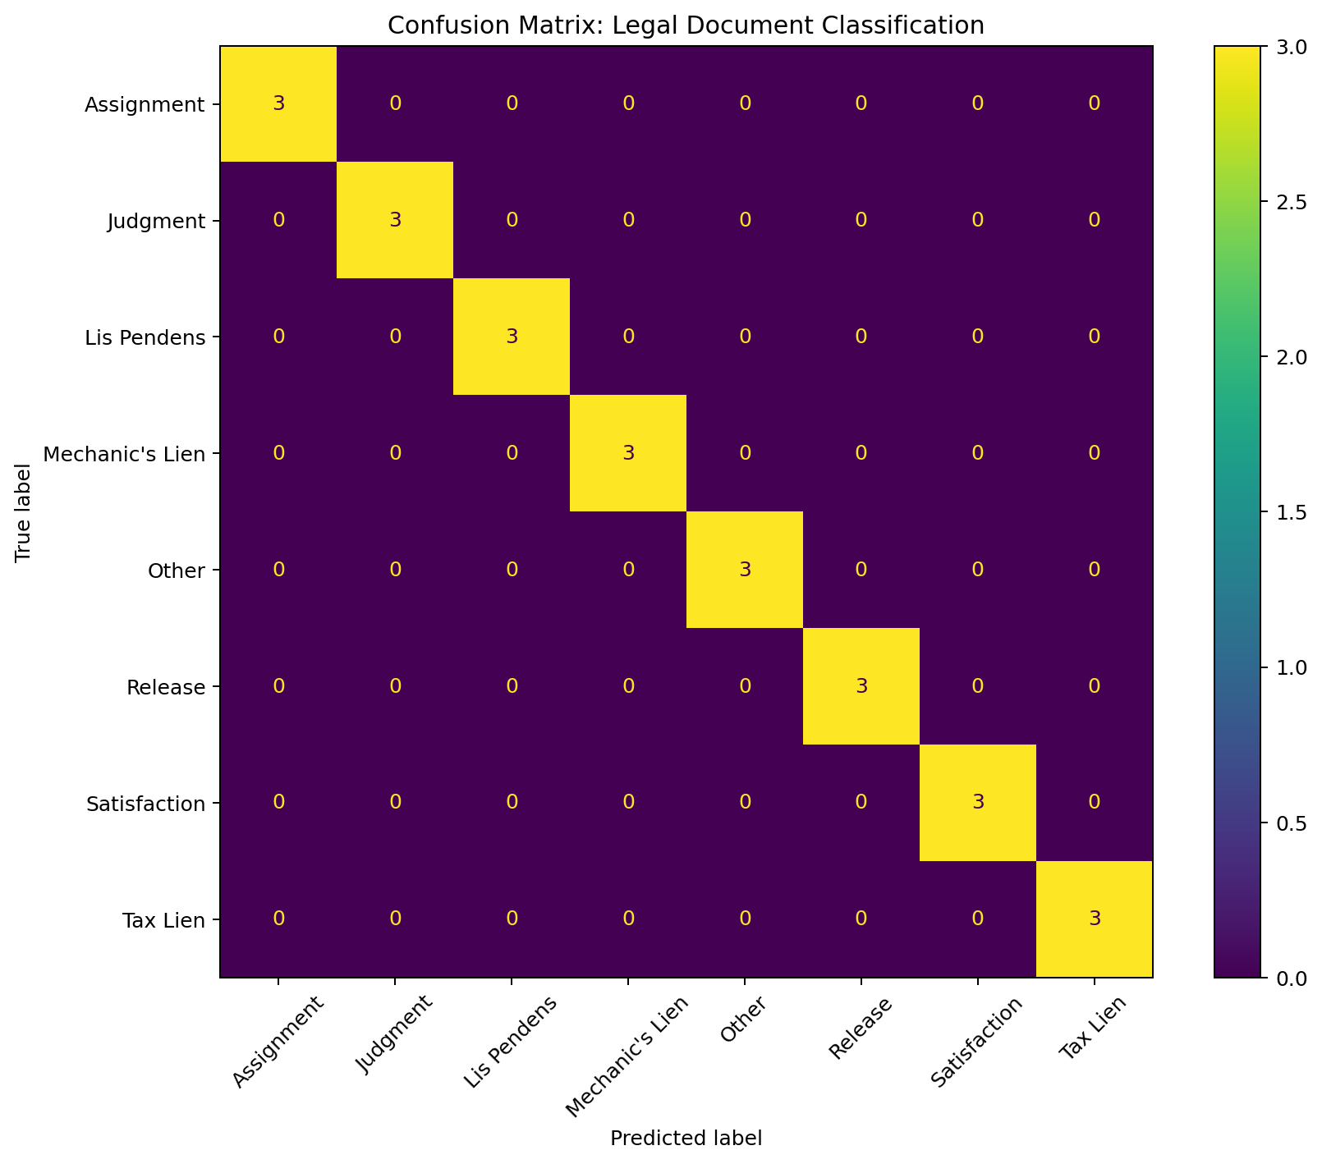
Figure 1. Confusion matrix for the simulated legal-document test set.
The result demonstrates that the workflow can distinguish clearly written simulated documents. However, the perfect score does not mean the system is ready for production. The test records use recognizable terminology and controlled formatting. Real documents may contain OCR errors, stamps, handwriting, missing pages, unusual abbreviations, multiple instruments, or ambiguous legal effects. The errors that would matter most are confusing a release or satisfaction with an active lien, missing a lis pendens, or misclassifying a tax lien, because those mistakes could affect title review, payoff handling, compliance, or foreclosure activity.
The prototype also estimates possible time savings. Using transparent assumptions of six minutes for a manual first review and 2.5 minutes for an AI-assisted review, a monthly volume of 2,500 documents would require about 250 manual hours versus 104.2 AI-assisted hours. The estimated reduction is 145.8 hours, or 58.3%. This is an illustrative estimate that should be validated through an actual time study.

Selected Results
Test Documents | Correct | Accuracy | Baseline Accuracy
24 | 24 | 100.0% | 12.5%

7. Ethics, Privacy, and Limitations
Bias and fairness concerns arise if a model is trained mainly on records from certain counties, document vendors, scanning systems, or legal formats. It may then perform worse on other jurisdictions or on documents associated with less-represented communities. A production system should be tested across counties, document types, image quality levels, languages, and operating teams. Performance should be monitored over time, and analysts should be able to correct model outputs.
Privacy is especially important because real mortgage documents may contain borrower names, property addresses, loan numbers, financial information, court details, and other regulated or confidential information. The organization should use data minimization, masking, encryption, role-based access, multifactor authentication, audit logs, retention rules, and approved private AI environments. Employees should not upload sensitive records to public AI tools.
The model is relatively explainable because managers can review important text features, predicted probabilities, and the original source text. Nevertheless, a probability score is not a legal explanation. The dataset is small, simulated, and intentionally structured. Operationally, the system would require OCR services, secure storage, model monitoring, staff training, exception handling, maintenance, and periodic retraining. Model changes should be documented and approved, and final business decisions should remain with trained personnel.

8. Conclusion and Business Impact
This project developed a working Python proof of concept that classifies and summarizes simulated mortgage-servicing legal documents. The model uses TF-IDF and logistic regression to predict eight document categories, extracts selected facts, generates a standardized first-review summary, and flags low-confidence cases for human review. It achieved 100% accuracy on a small, controlled test set and demonstrated how AI could reduce repetitive review time and improve consistency.
The recommendation is to proceed only to a limited pilot, not immediate production deployment. A pilot should use a larger, de-identified, analyst-labeled dataset from multiple counties and document formats. The organization should compare AI-assisted reviews with independent human reviews, measure false-negative risks, validate time savings, and obtain approval from legal, compliance, information security, and data-governance teams. Next steps include OCR testing, named-entity recognition, more realistic documents, model calibration, an analyst feedback loop, and possible integration of a secure enterprise LLM for richer summaries.

References
Consumer Financial Protection Bureau. (2024). Rules on mortgage servicing. https://www.consumerfinance.gov/compliance/compliance-resources/mortgage-resources/mortserv/
Fannie Mae. (2026). Lender Letter LL-2026-04: Governance framework on use of artificial intelligence and machine learning. https://singlefamily.fanniemae.com/
IBM. (n.d.). What is natural language processing (NLP)? IBM Think. https://www.ibm.com/think/topics/natural-language-processing
Microsoft. (n.d.). What are large language models (LLMs)? Microsoft Azure. https://azure.microsoft.com/en-us/resources/cloud-computing-dictionary/what-are-large-language-models-llms
Taulli, T. (2019). Artificial intelligence basics: A non-technical introduction. Apress.

Appendix A: Key Code Snippets
Model pipeline
model = Pipeline([
("tfidf", TfidfVectorizer(ngram_range=(1, 2), stop_words="english")),
("classifier", LogisticRegression(max_iter=2000, random_state=42))
])
model.fit(X_train, y_train)
Evaluation
predictions = model.predict(X_test)
accuracy = accuracy_score(y_test, predictions)
print(classification_report(y_test, predictions))
Human-review threshold
REVIEW_THRESHOLD = 0.60
results["review_required"] = (results["confidence"] < REVIEW_THRESHOLD)

Appendix B: Selected AI Assistance and Notes
ChatGPT was used to help organize the notebook, draft comments, and debug Python syntax. The final model logic, variables, outputs, and business interpretation were reviewed in plain language. The implementation does not call an external LLM API and does not send data outside the notebook. The most useful assistance involved structuring the TF-IDF and logistic-regression pipeline, writing extraction functions, and explaining evaluation metrics. The code was kept intentionally simple so each step could be explained.

Appendix C: Dataset Categories
- Mechanic's Lien: Claim for unpaid labor or materials that may affect title.
- Lis Pendens: Notice that pending litigation may affect the property.
- Judgment: Court-awarded debt that may attach to property.
- Tax Lien: Government claim for unpaid taxes.
- Release: Document discharging a previously recorded lien.
- Satisfaction: Document confirming a judgment has been paid.
- Assignment: Transfer of mortgage or related rights.
- Other: Recorded instrument outside the seven primary categories.

